SAMBOT – Unit Tests

**Content table**

Content table ……………………………………………………………………………………………………………………. 1

Introduction………………………………………………………………………………………………………………………. 1

Unit Tests………………………………………….………………………………………………………………………………. 2

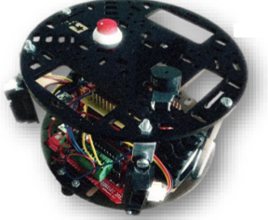

Introduction

SAMBOT is a tiny robot that is controlled by UART. It is composed of a master and a slave card. The first one controls the wheels depending of the information it receives from the second, which manages the sensors.

This document lists the different unit tests.

Every Unit Test is composed of:

-One unique ID following this pattern: SAMUT_XXX (Three digits).

-A function name to know what is being tested.

-A text explaining what the test is about.

SAMUT_001

Function name: Detect_Hole

Text: When there is no hole the function shall return 0. When there is, it shall return 1.

SAMUT_002

Function name: Detect_Obstacle

Text: The function shall return a range included in [0;20] cm if there is an obstacle. If not, the function returns 30.

SAMUT_003

Function name: Turn_Servo

Text: This function shall return the angle of the servomotor. When active the servomotor shall turn.

SAMUT_004

Function name: SB_Forward

Text: When active, the wheels shall turn to move the robot forward.

SAMUT_005

Function name: SB_Stop

Text: When triggered, the wheels shall stop.

SAMUT_006

Function name: Turn_Robot

Text: When active they shall turn on right is 1 is entered, on left if 2 is entered. If something else is in parameter, the function shall do nothing.

SAMUT_007

Function name: Emergency_Stop

Text: If the button is pressed, the wheels shall stop instantly.

SAMUT_008

Function name: Bluetooth_Connect

Text: When the launchpad is started, it sends a message telling the computer that they are connected. It says “MSP430 READY!”